Create a declarative pipeline to build, test a spring pet clinic application • Steps: • Create a pipeline project DeclarativePetClinic Code is available in Jenkinsfile of <https://github.com/AnjuMeleth/spring-petclinic.git>

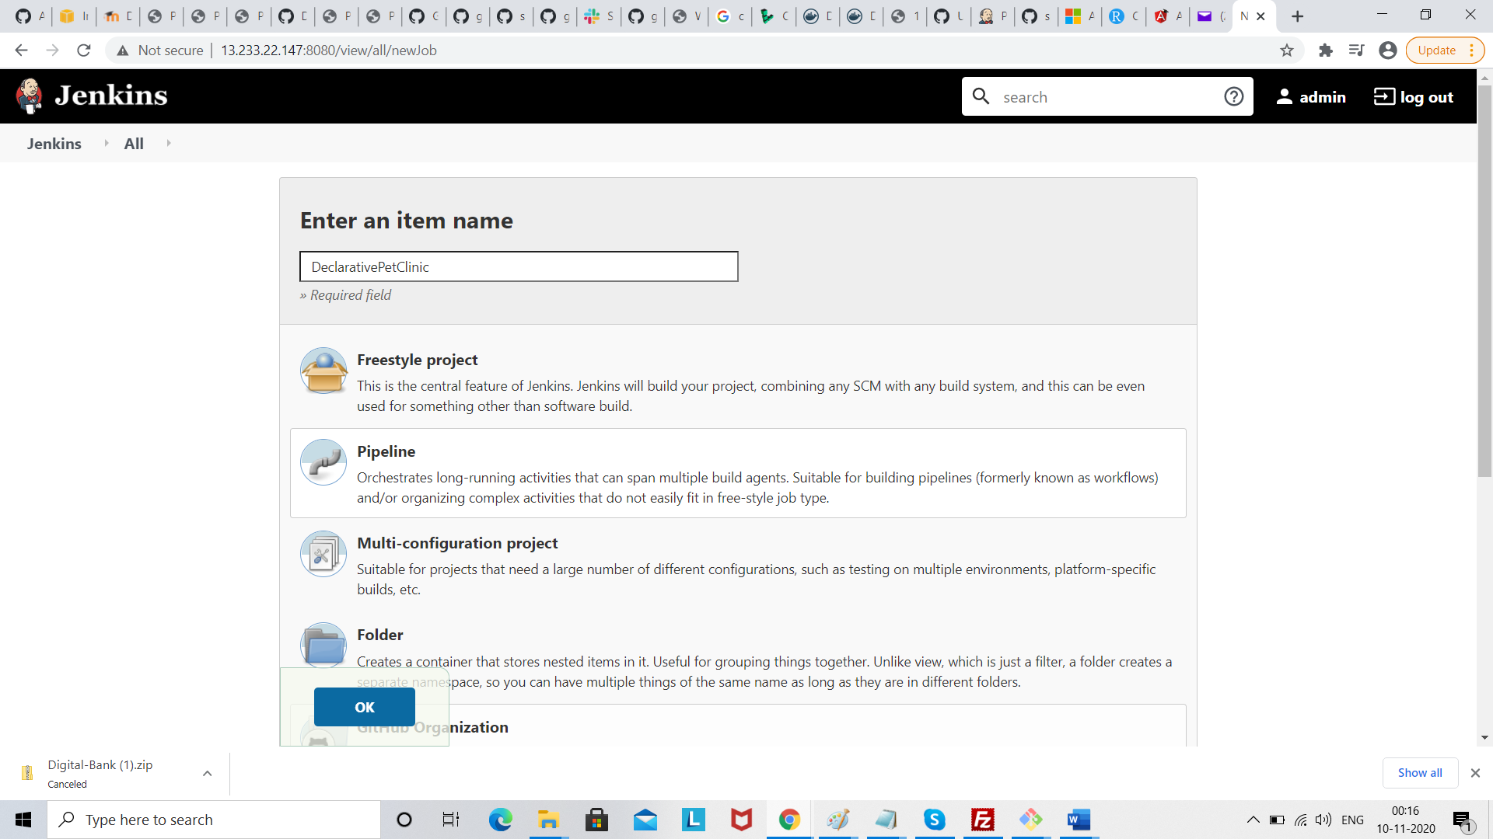

Click pipeline project .click ok

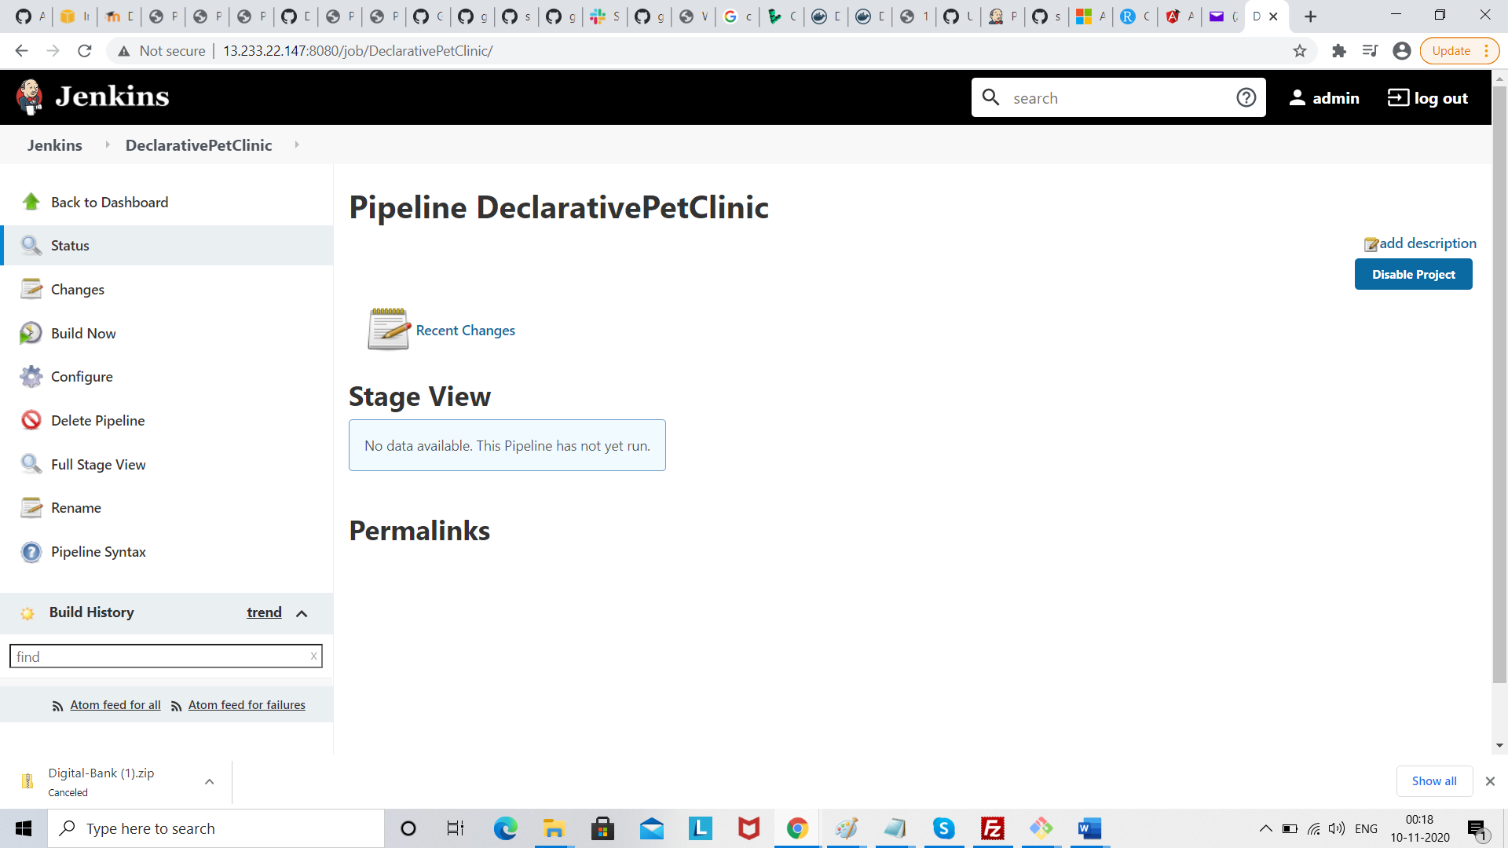

Click build

